LAB00 Huỳnh Đại Lục

7.1
Edition Windows 11 Home Single Language
Version 25H2
Installed on ‎11/‎26/‎2024
OS build 26200.9168
Experience Windows Feature Experience Pack 1000.26100.344.0

Device name MSI
Processor 12th Gen Intel(R) Core(TM) i5-1235U (1.30 GHz)
Installed RAM 16.0 GB (15.7 GB usable)
Device ID 5691E1B2-8CC9-43F8-9D91-DA6EE99456F8
Product ID 00342-42654-92437-AAOEM
System type 64-bit operating system, x64-based processor
Pen and touch No pen or touch input is available for this display

7.2

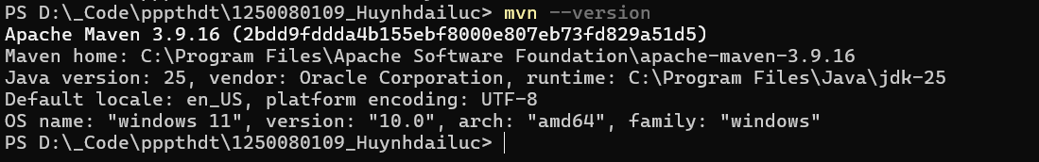
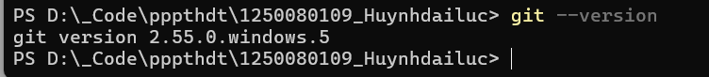

7.3
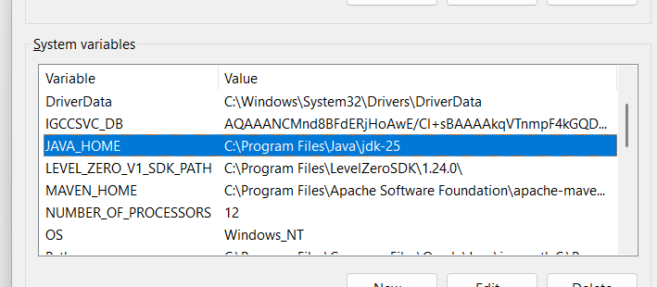
7.4
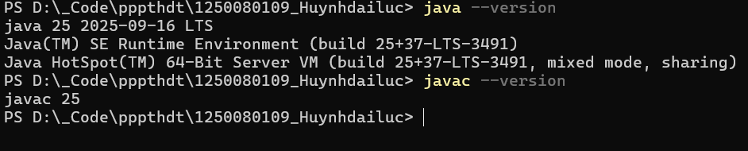

7.5
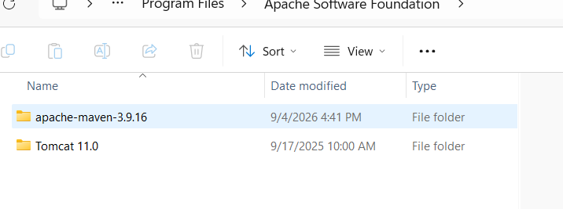

7.6

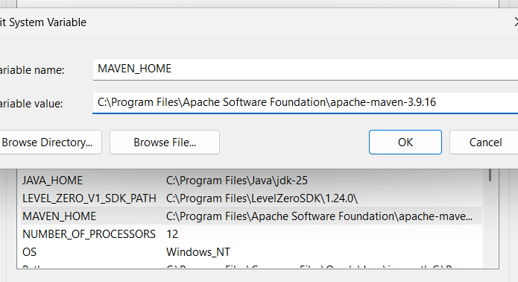
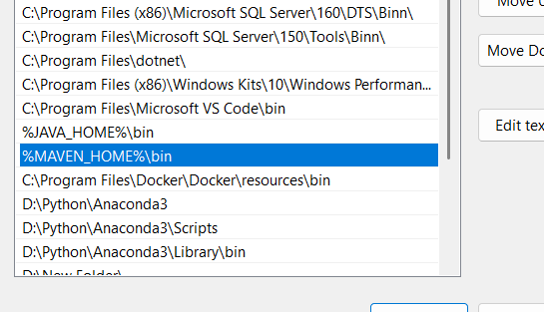

7.7
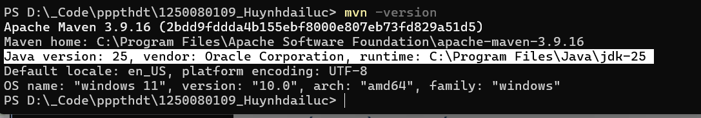

7.8

7.9
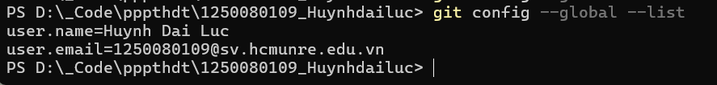
7.11

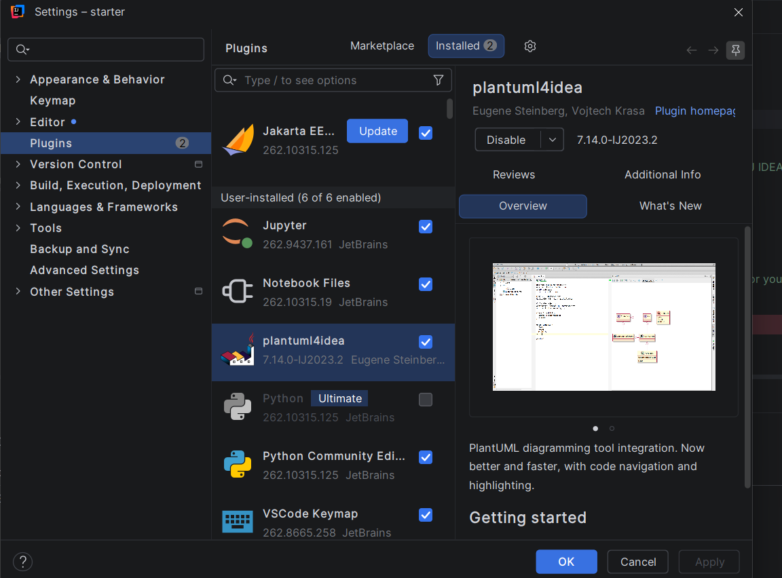
7.12

